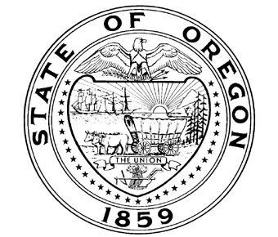
Oregon Travel Information Council
1500 Liberty Street SE, Suite 150
Salem, Oregon 97302

EXECUTIVE COMMITTEE
Executive Session Special Meeting Agenda
May 3, 2016 – 9:00 a.m.
Oregon Department of Justice Commerce Building
158 12th Street NE, Salem, Oregon 97302
Executive Session
The Executive Committee of the Travel Information Council will hold an executive session for the sole purpose of meeting with legal counsel regarding pending litigation. The executive session is being held pursuant to ORS 192.660(2)(f) [consideration of information or records exempt from public inspection], and (h) [consultation with legal counsel]. No final decisions or actions will be made in Executive Session.

Call to order in Executive Session:
- Meeting with legal counsel.

Adjourn:
- Next meeting: None scheduled.

_______________

